Homework-12

Assigned: December 8, 2024 (Sunday)
Graph Algorithms: Topological Sort, Shortest Path, MST, Maximum Flow
Due: December 15, 2024 (Sunday)

Problem 1: What is travelling salesman problem? Give algorithms for dynamic programming and greedy approaches. Find the optimal tour using dynamic programming and suboptimal tour using greedy approach and minimum spanning tree for a G(V,E) where V={1,2,3,4} and cost of the edges are given by cost matrix S_{ij}.
- 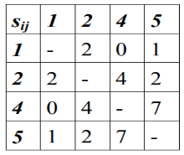
- 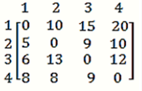
- “The cost of the minimum spanning tree is always less than the cost of the optimal tour”. Justify the statement.

Problem 16: What is TSP? Give its dynamic algorithm? Find the least cost path in the following graph represented by adjacency matrix?


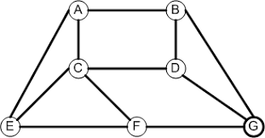
Problem 17: What is approximation ratio? Explain vertex cover problem? Give a 2-approximation algorithm for vertex cover problem. Find the vertex cover in the following graph using the above algorithm.

Problem 21: Explain P and NP problems. What is NP-complete and NP-Hard Problems.

Problem22: Graph Coloring

